**Lab 4: Disk Image and Partitions**

**Group: CyberSec_N00b**

#### Member:

#### Huỳnh Ngọc Quang (SE181838)

#### Hồ Tài Liên Vy Kha (SE181818)

#### Hoàng Kim Long (DE180860)

#### Phạm Thành Long (SE181692)

#### Nguyễn Lê Hoàng Thông (SE182533)

1. **Verify the integrity of the disk image**

* Create Lab Folder

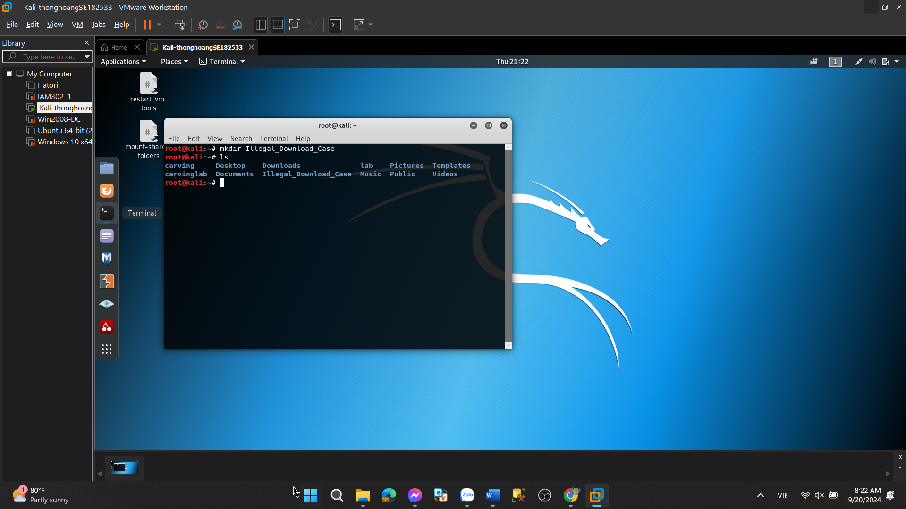

* Download Case Materials

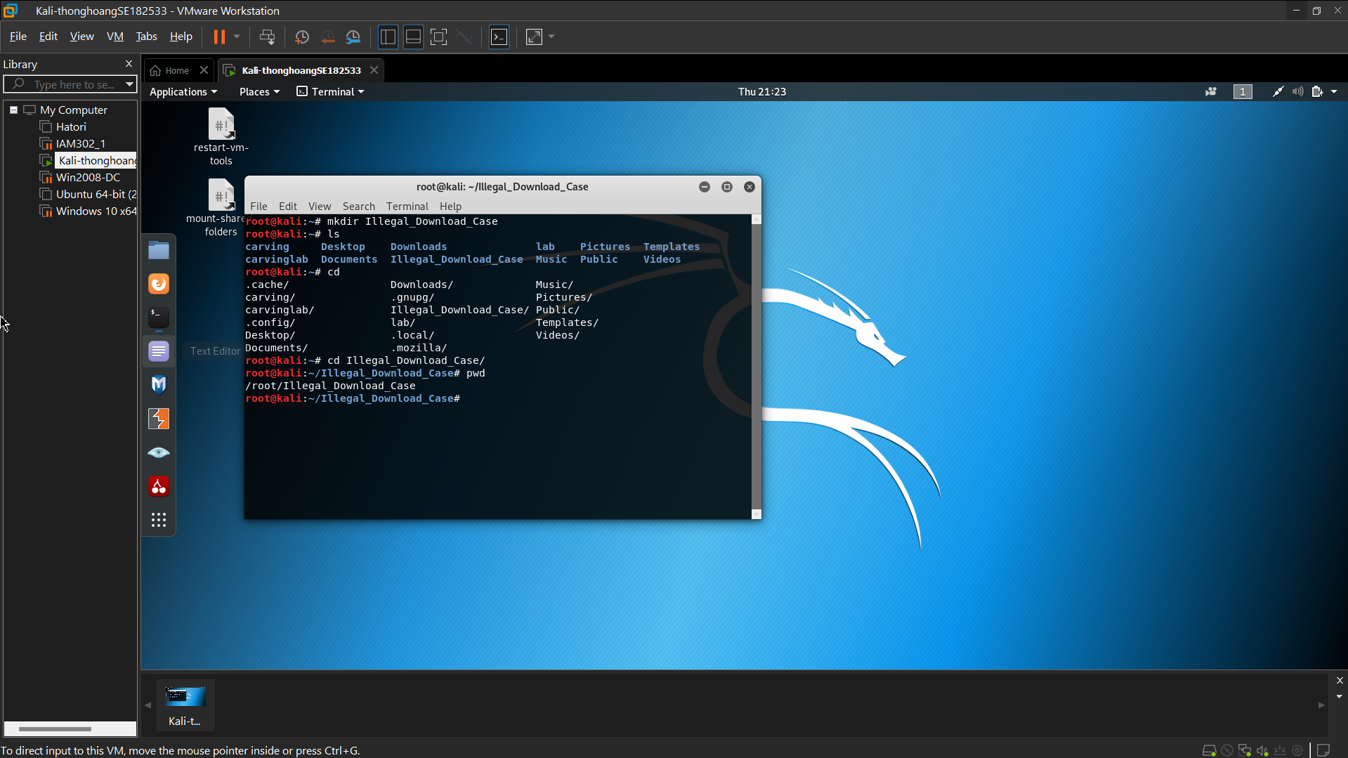 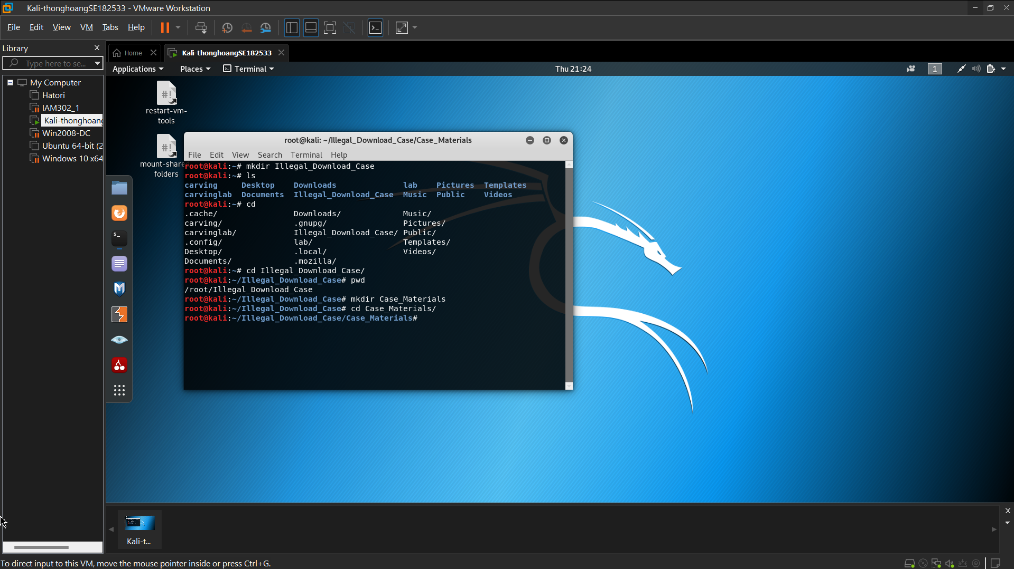

* Use *wget* to download disk image. ( about 30GB ) Install Necessary Software
  + Hashdeep
  + Md5deep

sudo apt install hashdeep

**Step 2.**

Generate an MD5 and SHA1 hash of the disk image. These tools will compare the MD5 and/or SHA1 hash of the disk image to the MD5 and/or SHA1 hash in the ‘*hash_reference.txt*’ file.

Commands

* + *md5deep <disk image> -bewM <file that contains file names and hash codes>*

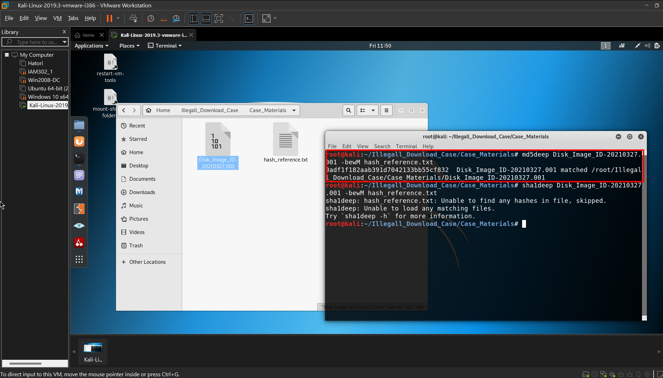

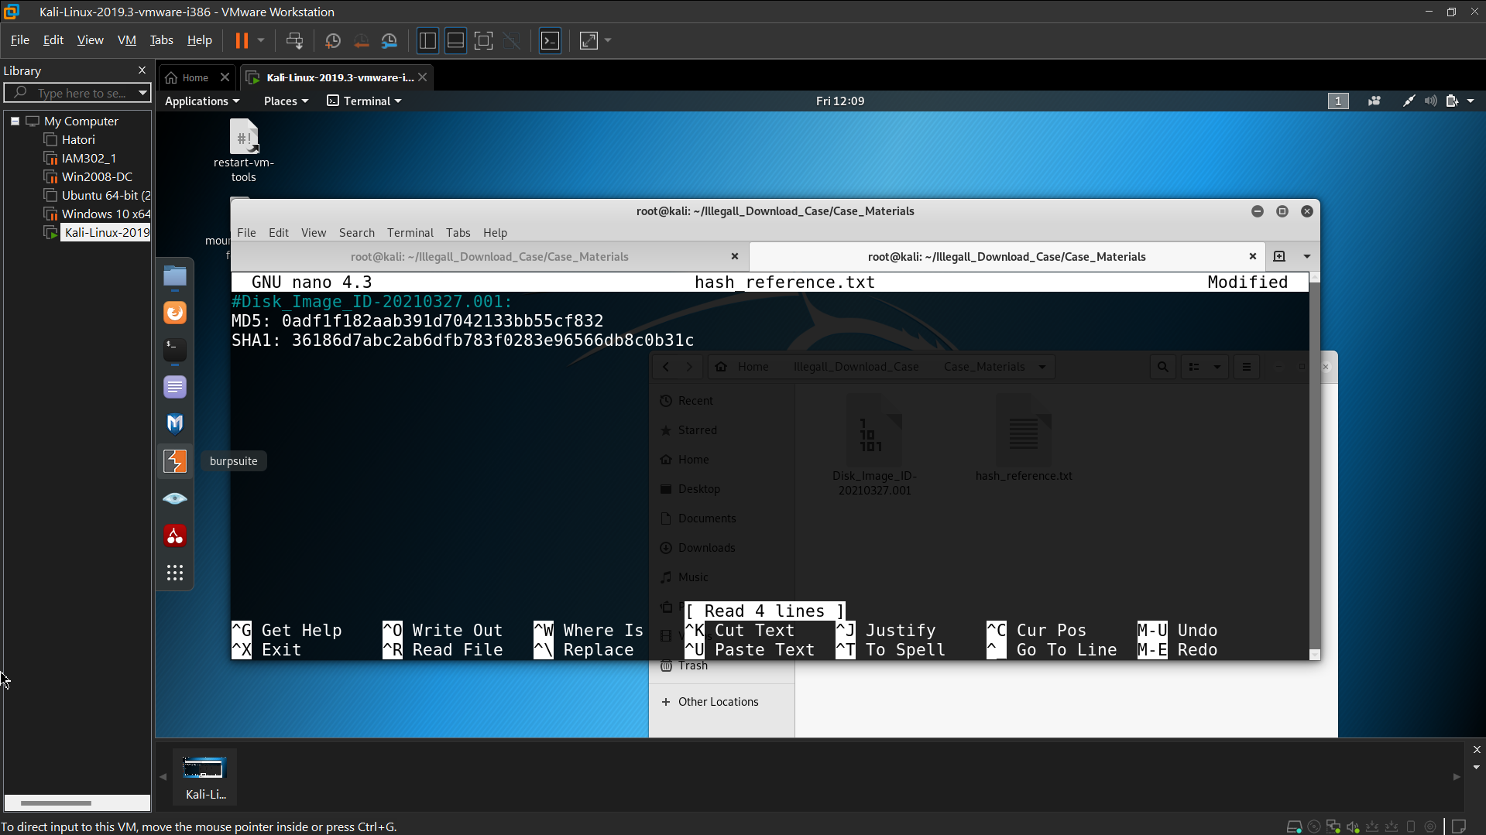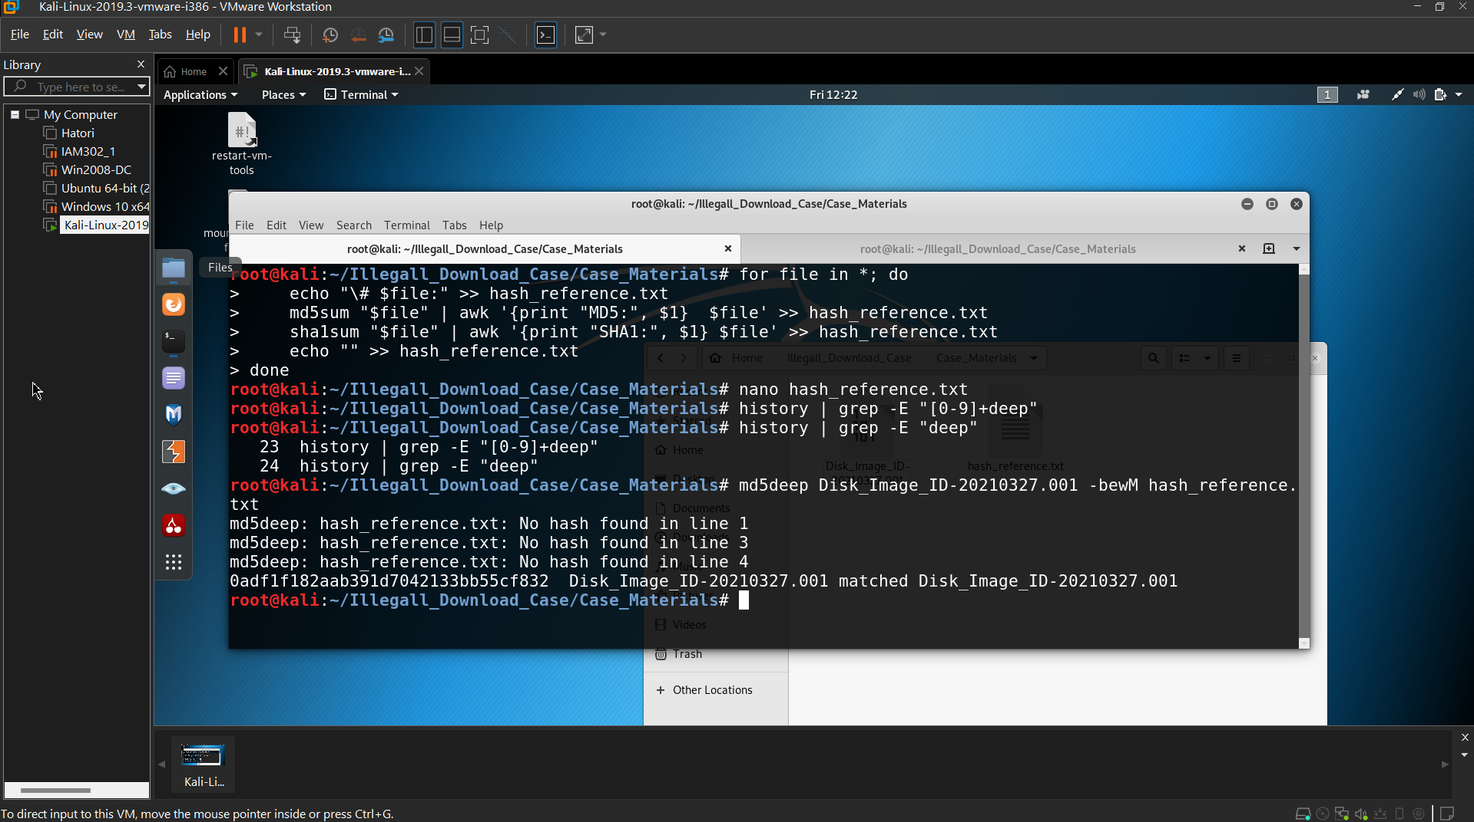

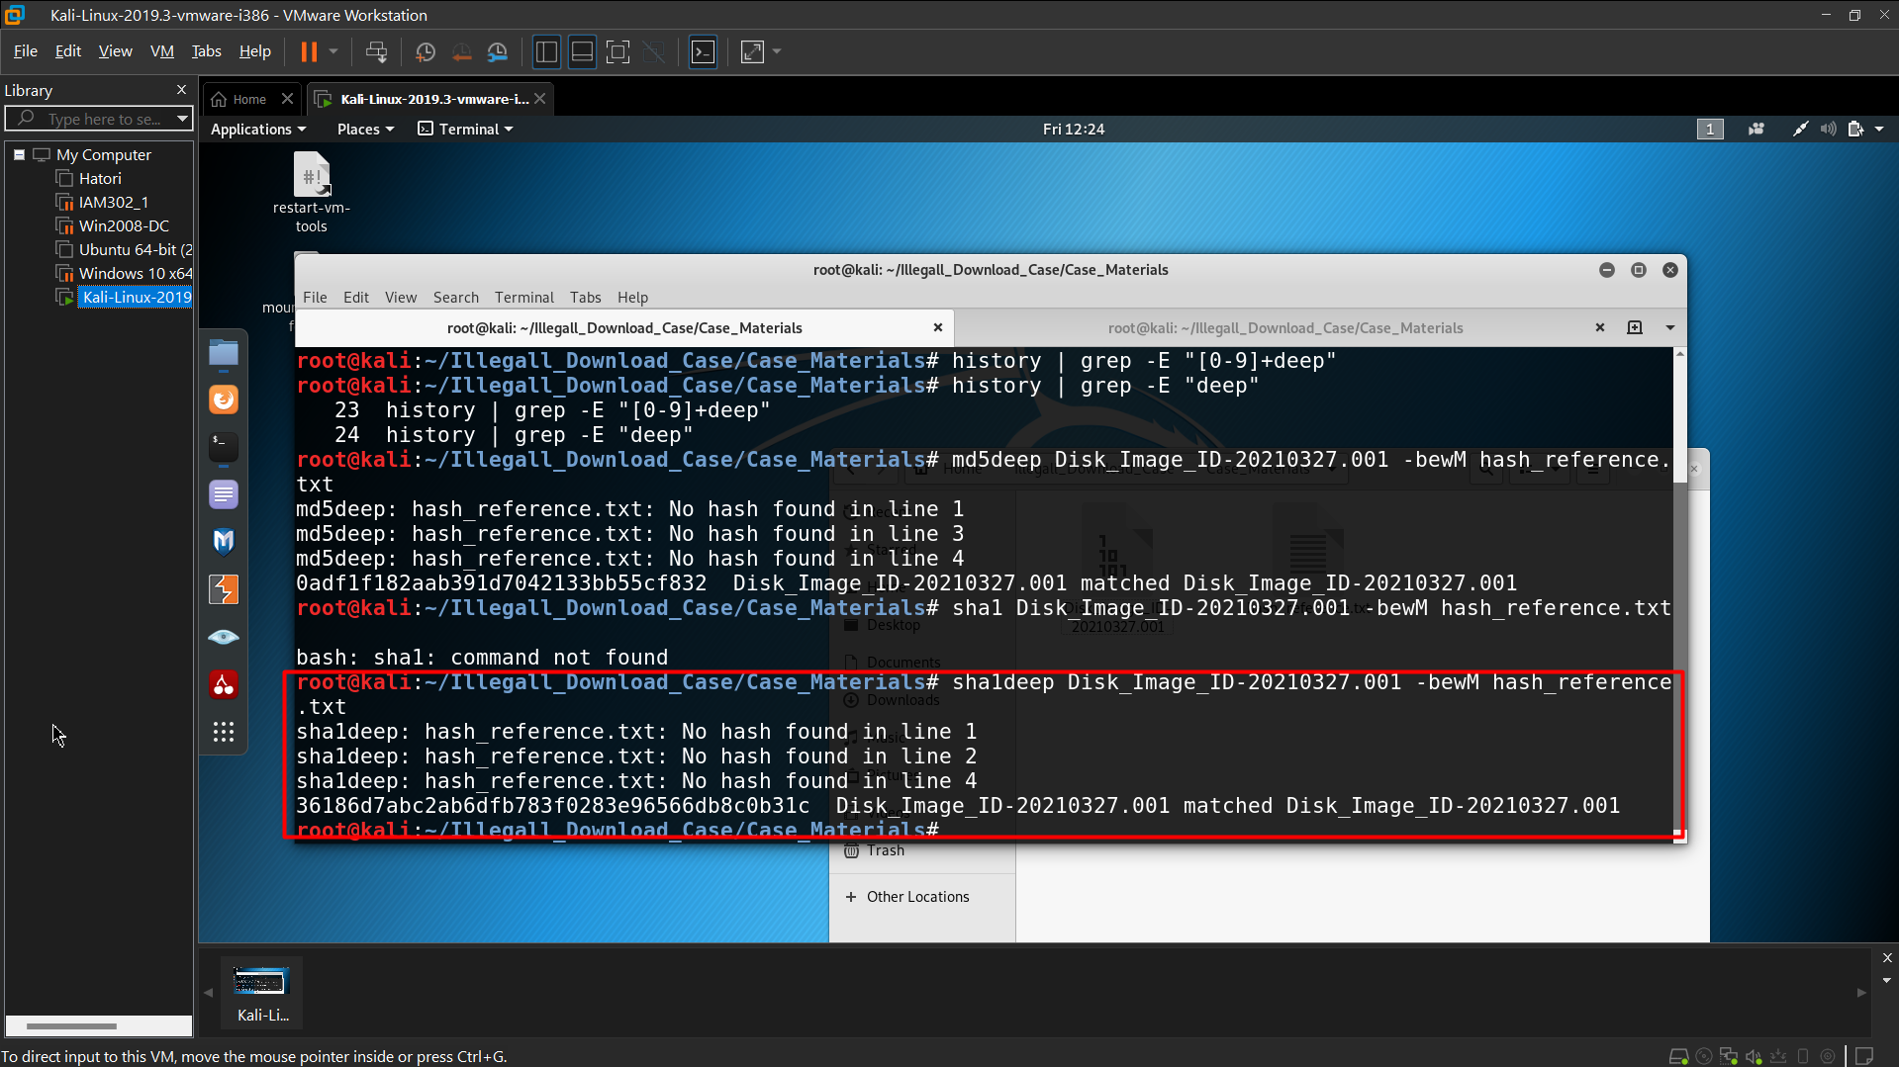

* + Note: You would replace <disk image> with the file path to the disk image. The same applies to anything else contained in between ‘< >’.
* Use MD5deep to verify the MD5 hash of the disk image.
* Use SHA1deep to verify the MD5 hash of the disk image.

**2. Identify the OS of the system as well as its name, accounts, and partitions.**

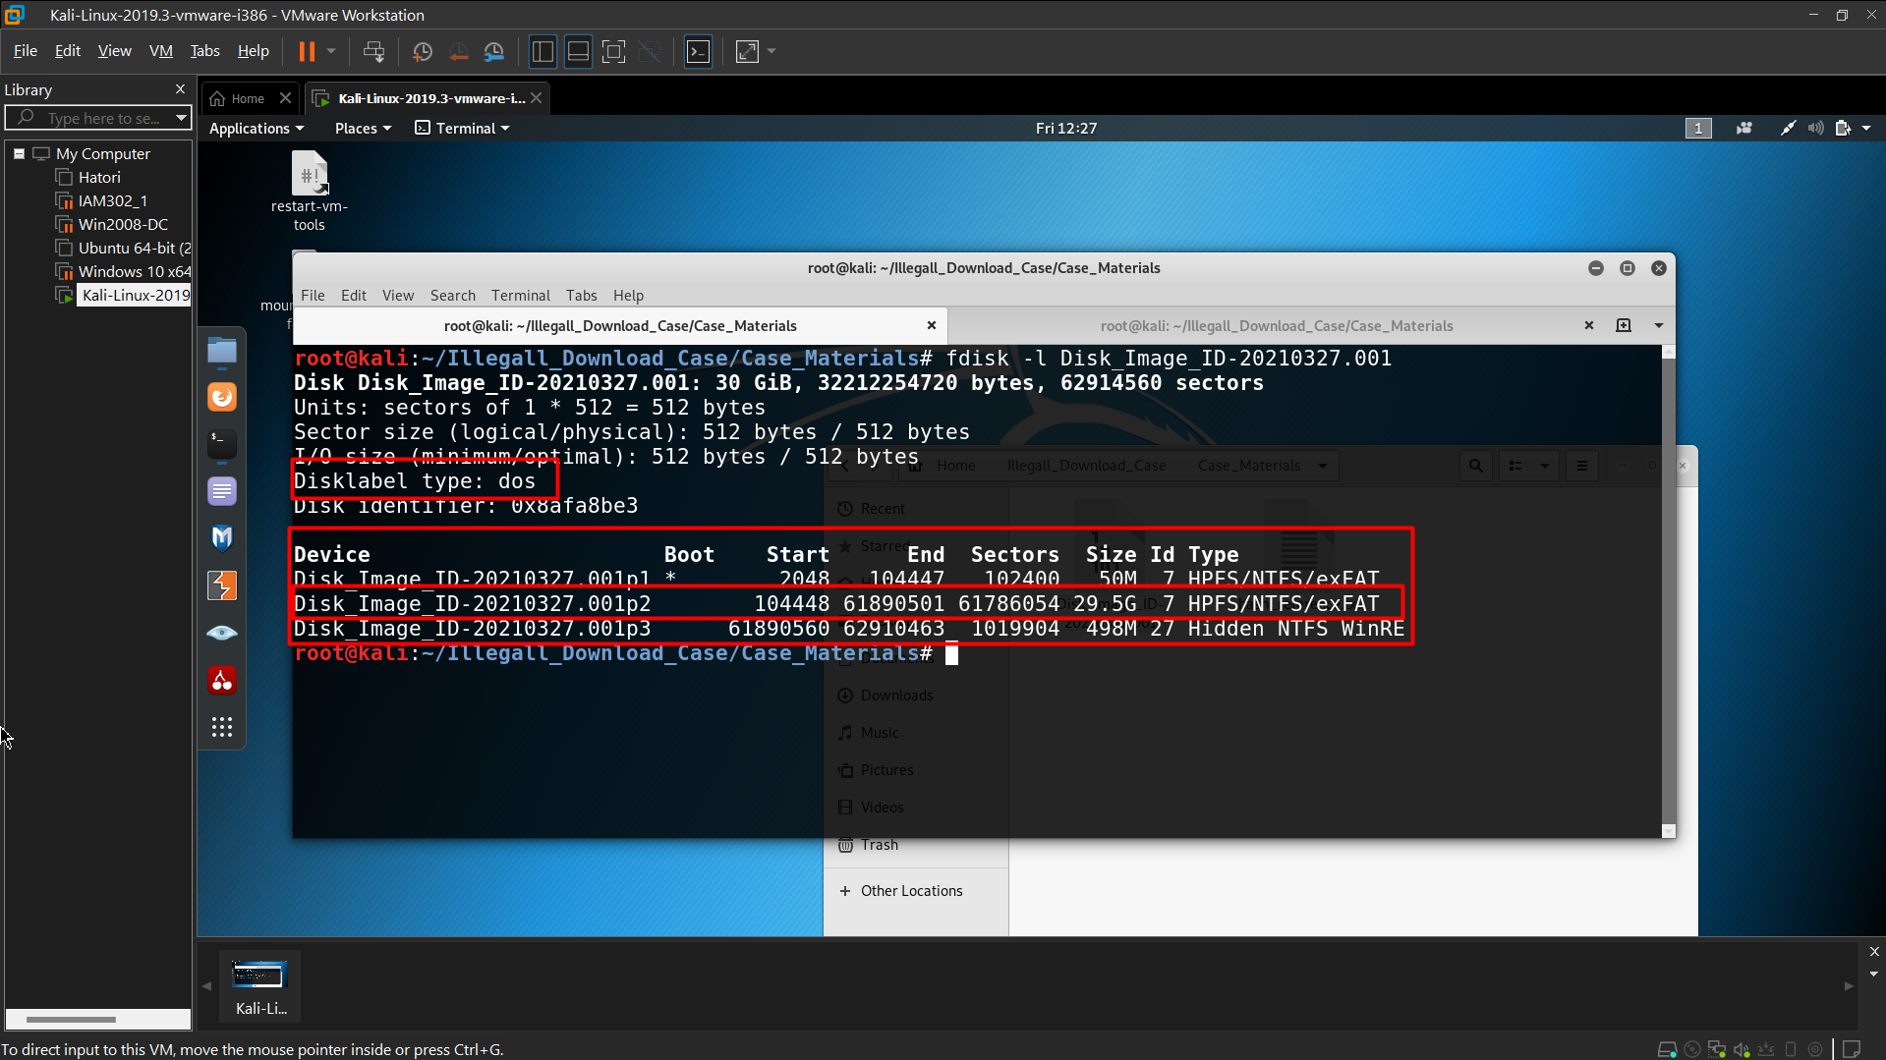

Volume offset #s (in sectors):

* Partition 1 – 2048
* Partition 2 – 104448
* Partition 3 – 61890560
* How to get help for *fsstat*
* Use *fsstat* to get file system details.

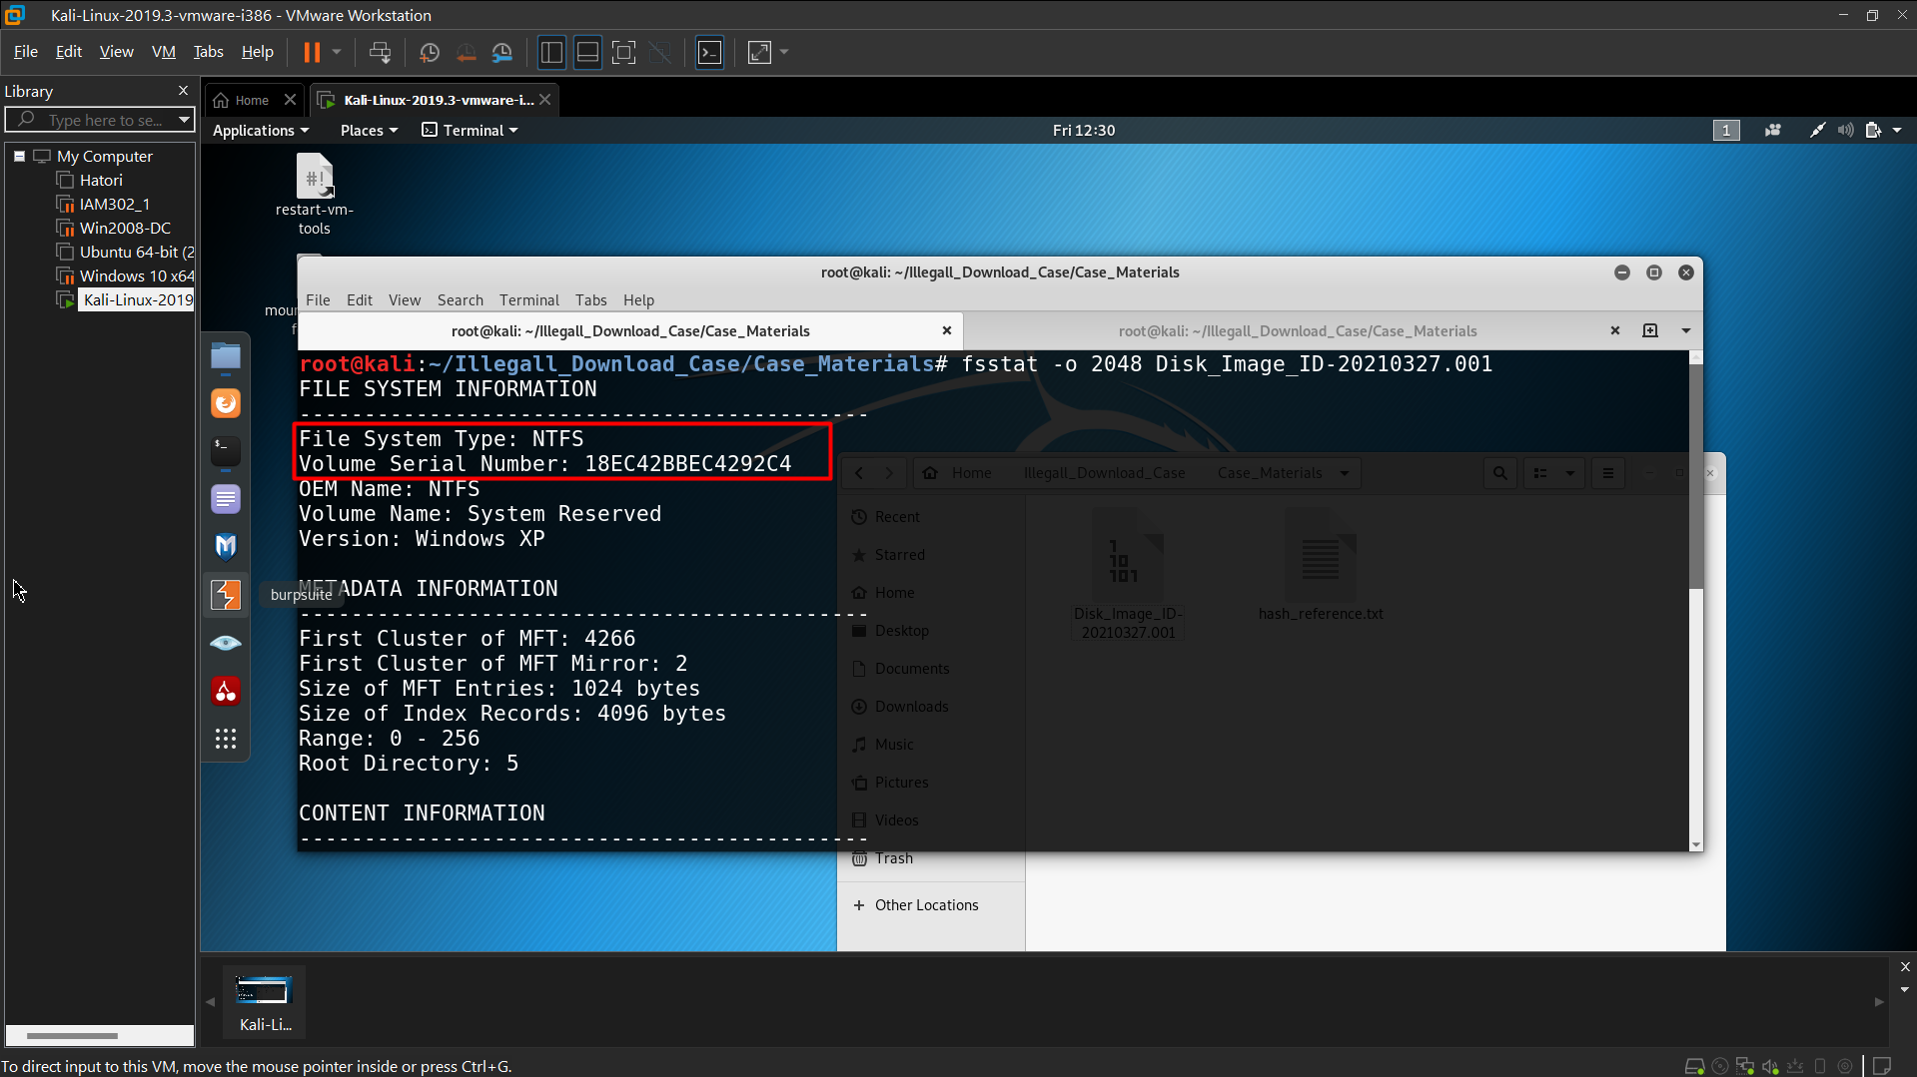 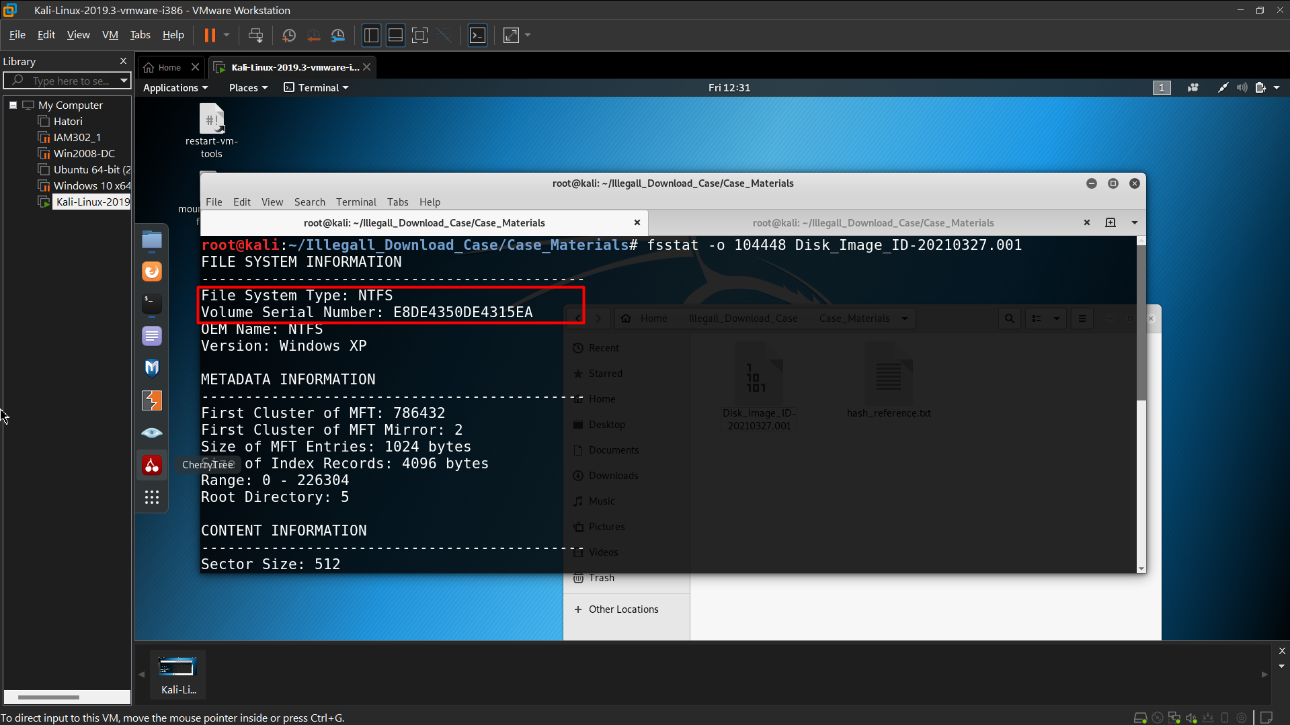 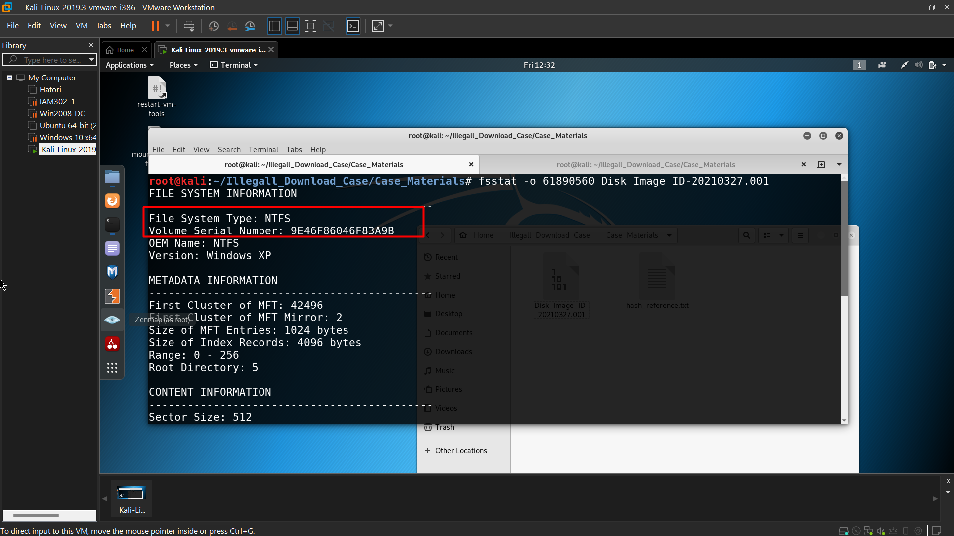 Partition 1

File System: NTFS

Serial Number: 18EC42BBEC4292C4

Partition 2

File System: NTFS

Serial Number: E8DE4350DE4315EA

Partition 3

File System: NTFS

Serial Number: 9E46F86046F83A9B

* Using *fdisk* and *fsstat*, we obtained this information:

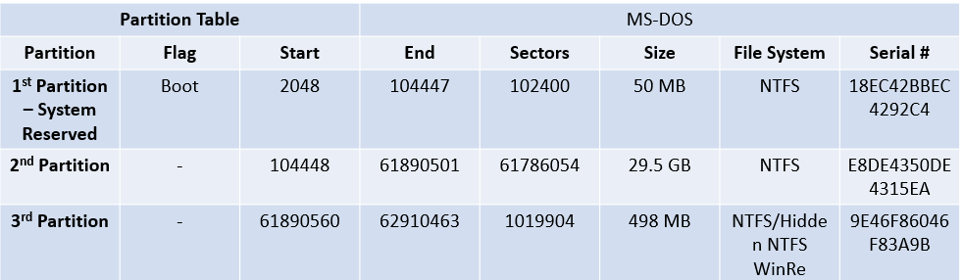 Please explain the parameters in the table ?

1. Flag: Indicates special attributes of the partition.

- For the 1st Partition, it is flagged as **Boot**, meaning it contains the boot loader necessary for starting the operating system.

2. Start and End: These columns indicate the starting and ending sector numbers for each partition on the disk.

- Start: The sector where the partition begins.

- End: The sector where the partition ends.

3. Sectors: This is the total number of sectors occupied by the partition. Each sector typically has a size of 512 bytes.

4. Size: The total size of the partition, calculated based on the number of sectors.

5. File System: This indicates the type of file system used on the partition.

- In the image, NTFS (New Technology File System) is used, which is commonly found on Windows systems.

6. Serial#: This is the unique identifier for each partition. The serial number is generated when the file system is created.